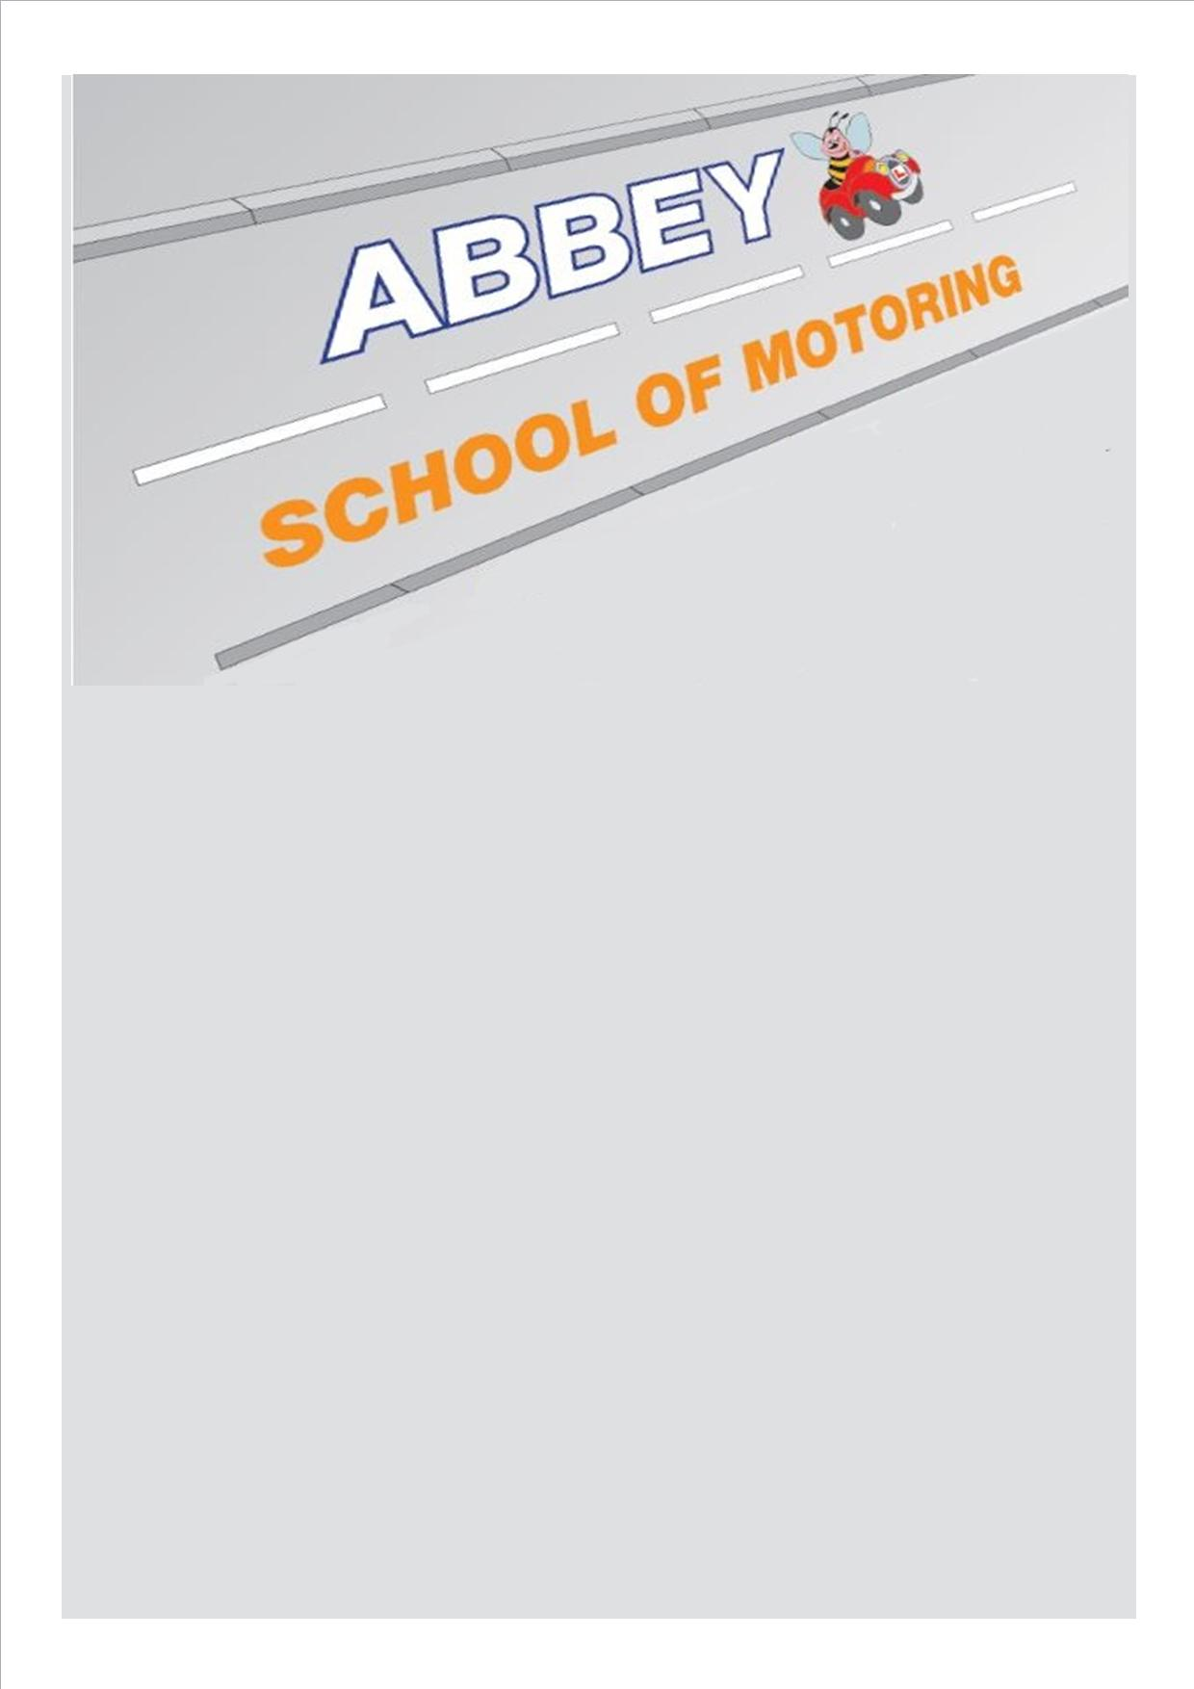

**Looking to pass you’re driving test as quick as you can?**

**CALL TODAY!**

**0800 11 200 62**